Reg. Charity No. 1129395
Patron – Rhodri Glyn Thomas A.M.
www.westwalesprostatecancer.org.uk

We are a patient-led prostate cancer support group for men and their partners living in West Wales.
We aim to give men the opportunity to talk to other men who have been through the experience of tests, diagnosis and treatment for prostate cancer.
We encourage men with prostate cancer or symptoms of prostate disease to become better informed and able to discuss and make decisions about their treatment.
We encourage all men from age 50 to seek professional advice and request regular tests from their own GP to identify any abnormality of the prostate gland.
We work with other agencies to improve awareness, education, diagnosis, therapy and support for men with prostate cancer.

CONFIDENTIAL HELPLINES:
01559 363154
01834 831442
01239 710265
07870 917806

www.westwalesprostatecancer.org.uk

Member of the Prostate Cancer Support Federation

YOUR PROSTATE & YOU
By patients, for patients
The prostate is located in the pelvic area. It sits directly beneath the bladder and surrounds the urethra. It is an essential part of the male reproductive system. It manufactures semen and acts as a valve, helping to control the flow of semen and urine through the urethra to the penis. A healthy prostate is about the size of a walnut.

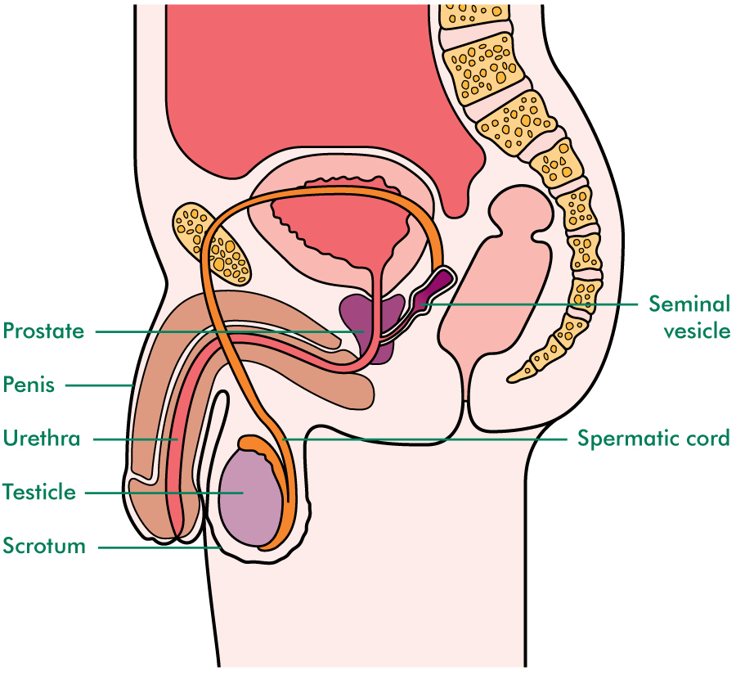

Diagram. Macmillan Cancer Support

DISEASES OF THE PROSTATE.

PROSTATITIS. Inflammation of the prostate. Most at risk are men aged 30-50. This disease can become chronic and difficult to treat.

BENIGN PROSTATIC HYPERPLASIA. (BPH, ENLARGED PROSTATE). Most at risk are men aged 60+. A common age related disease.

PROSTATE CANCER. Most at risk are men aged 50+, African Caribbean men, and men with a family history of breast or prostate cancer.

PROSTATE CANCER: SOME FACTS.
- Over 11,000 men die from prostate cancer in the UK every year.
- Early prostate cancer usually has no symptoms; if it can be found and treated, it can be cured. No symptoms does not mean no cancer.
- Some slow growing prostate cancers can be monitored to delay or even avoid treatment.
- More aggressive cancers need urgent treatment.
- A blood test (PSA) will usually detect disease in the prostate. A raised PSA score will need further investigation to establish the cause.
- A third of men with a raised PSA will have prostate cancer.
- At aged 50, men are entitled to a regular blood test (ask your doctor). Men most at risk should consider an annual test. Always keep a record of your results.
- Men have a 1 in 8 lifetime risk of being diagnosed with prostate cancer in the UK.

SYMPTOMS OF PROSTATE DISEASE.
Possible symptoms of enlarged prostate, prostatitis or prostate cancer.
- Difficulty in starting to urinate
- Straining or taking longer to urinate
- A feeling that the bladder has not emptied
- Intermittent flow
- Difficulty in stopping urination
- Dribbling after urination
- More frequent urination, day and night
- Urgency, inability to postpone urination
- Pain/burning sensation when urinating
- Problems achieving/maintaining an erection
- Blood in the urine or semen
- Pain/discomfort when ejaculating
- Delayed ejaculation, reduced ejaculate (semen)
- Pain in the perineum/testicles
- Unexplained pain in the back, hips or pelvis

BUT REMEMBER, PROSTATE CANCER IS OFTEN ‘SILENT’ WITH NO SYMPTOMS FOR MONTHS OR YEARS.

Why does early prostate cancer have no symptoms?
The prostate gland is made up of several zones. Most prostate cancers occur in the outer, peripheral zone of the prostate. They grow outwards away from the urethra and do not affect the flow of urine/semen. Non-cancerous enlargement (BPH) occurs in the inner, transitional area of the prostate and grows towards the urethra which is constricted causing some of the above symptoms.
Because of its lack of early symptoms, prostate cancer is often found by accident when doctors investigate other health issues and carry out a precautionary PSA test. Men with advanced prostate cancer may not be diagnosed until the cancer has spread to the bone causing hip, pelvic or lower back pain.

PROSTATE CANCER DIAGNOSIS
All too often, prostate cancer is diagnosed when otherwise unexplained symptoms, e.g. lower back pain are investigated.
If you have any of the symptoms listed, don’t ignore them; see your GP without delay. If you are symptom free and aged 50, consider asking your GP for a PSA (blood) test. A higher than normal score will indicate the presence of prostate disease. This test should be repeated every 12 months and the score recorded.
THE PSA TEST: Prostate Specific Antigen is a protein produced in the prostate gland. It is normal for all men to have traces of this protein in their blood where it can be measured in nanograms per millilitre of blood (ng.ml). Disease will usually be reflected in a higher score but levels can rise temporarily for a number of reasons:
- A urine infection
- Vigorous exercise up to 48 hours before the test
- Ejaculation in the previous 48 hours
- A physical examination of the prostate
- A prostate biopsy up to 6 weeks before the test
Some drugs can lower PSA levels and can prevent or delay diagnosis. (Tell your GP if you are taking Finasteride/Dutasteride which can be prescribed for enlarged prostate. Soluble aspirin and statins can also lower PSA scores.)
Digital Rectal Examination (DRE): Symptoms of prostate disease and/or raised PSA levels should encourage GPs and hospital doctors to undertake a physical examination of the prostate. A DRE may embarrass but it is an essential part of a cancer diagnosis. Cancer can kill; a DRE will not! If a GP suspects cancer, he will refer you to a hospital specialist. An urgent referral should be seen within 10 working days.

The hospital doctor may order a biopsy of the prostate which takes small samples of prostate tissue. If cancer is found patients should be given a Gleason Score which indicates how aggressive the cancer is. Ask your consultant to explain what this means. If cancer is not found, but suspected, a further biopsy or an MRI scan may be ordered.
Other tests: Once cancer is diagnosed, your case will be discussed by a multidisciplinary team and you should be introduced to a Key Worker usually a specialist nurse who will support and inform you through your cancer journey. Further tests and scans will be ordered. These may include a computerized tomography scan (CT), a magnetic resonance imaging scan (MRI) and/or bone scan. These will ‘stage’ your cancer and help to establish if the cancer has spread beyond the prostate.
Treatment: If your cancer is contained within the prostate and your health is otherwise good, you should be offered a number of treatments aimed at curing your cancer. Active surveillance may be suggested in order to postpone treatment and the side effects of treatment.
Surgery, radiotherapy and brachytherapy can offer a cure as can cryotherapy and high intensity focused ultrasound (HIFU) though these two are more often used when other treatments have failed. Radiotherapy is usually preceded by a course of hormone therapy which may be continued for a further two to three years.

AM I AT RISK? Prostate cancer is usually a disease of middle aged and older men. Men over 50, those with a family history of prostate or breast cancer, and African Caribbean men are particularly at risk. Cases of prostate cancer can occur in younger men.
TREATMENT CHOICES
Caught early, a man diagnosed with prostate cancer can be cured and if otherwise fit, should have a choice of therapy. Not all treatments will be available locally. Men with advanced or locally advanced prostate cancer will have fewer options.

Active Surveillance or Watchful Waiting: treatments well worth exploring by men untroubled by symptoms yet diagnosed with slow growing localised prostate cancer. These can be an option, possibly for older men wishing to avoid treatment (Watchful Waiting), or younger men wishing to delay treatment (Active Surveillance). Both choices require regular PSA tests to monitor changes. Further biopsies/scans may be required every 2-3 years. Thus radical treatment and side effects can be avoided or postponed.
Brachytherapy: a treatment only used for localised prostate cancer. Up to 120 radioactive implants [seeds] are injected into the prostate via the perineum. The treatment takes up to 2 hours and may require 2 days in hospital.
Cryotherapy: a little used treatment for localised prostate cancer where frozen gasses [-40.c] are inserted into the prostate via the perineum to destroy the cancer. Hospital stay 24-48 hours.

External Beam Radiotherapy: radiation treatment generally used to destroy the cancer if it is contained within the prostate, or ‘locally advanced’. The prostate and immediate area is treated over a period of between 4 and 7 weeks. Patients who choose surgery may have radiotherapy if the cancer returns but surgery is not usually available as a post radiotherapy treatment due to the presence of scar tissue. Hormone therapy often precedes radiotherapy to reduce the tumour and make it more susceptible to treatment. Hormone therapy may be continued after radiotherapy.
3D Conformal Radiotherapy is most commonly used. The beam is shaped to fit the size and form of the prostate.
Intensity Modulated Radiotherapy is newer with fewer hospitals offering treatment. The beam is adjusted to give different doses to different parts of the treatment area. As with other forms of radiotherapy, it is generally available to men with localised cancer who cannot or choose not to have surgery.
Steriotactic Radiotherapy (e.g. Cyberknife) uses many low intensity beams over a much shorter period. A number of gold seeds, ‘fiducal’ markers, allow the radiographer to locate the exact position of the tumour prior to each treatment.
Radical Prostatectomy: removal of the prostate by surgery. A treatment for localised prostate cancer. As this requires major surgery, age and fitness are important considerations for this treatment. A hospital stay of between 3 and 6 days is normal followed by a long period of recuperation of 3+ months. Surgery may be ‘Open,’ ‘Keyhole’ or ‘Robotic Keyhole’ according to circumstances.

High Intensity Focused Ultrasound [HIFU]: a relatively new treatment for localised prostate cancer. The cancer is destroyed using a high energy ultrasound beam from a probe inserted into the prostate via the rectum. Likely hospital stay 24-48 hours.

Hormone Therapy: Prostate cancer needs testosterone to grow. Hormone therapy starves the cancer of testosterone. It can halt its growth and diminish the cancer. The effect of hormone treatment may be short lived if the cancer becomes resistant to this therapy. Hormone therapy can be used short term to improve the effectiveness of other treatments, intermittently to delay resistance to the treatment, or indefinitely, particularly for men with advanced [metastatic] or locally advanced prostate cancer. Some patients tolerate this treatment well, others do not. Treatment is taken orally and/or via a small implant usually injected beneath the skin of the abdomen or upper arm.
A less common treatment is the surgical removal of the testes [or orchidectomy], the source of testosterone.

Chemotherapy: is used for advanced disease when hormone therapy has lost its capacity to control the cancer. It still very much the subject of research projects. Newer chemotherapy drugs are more targeted, with fewer side effects. The aim is to shrink the cancer and relieve symptoms

New Developments: Newer drugs such as Abiraterone and Enzalutamide have been developed to extend life and improve the quality of life.

Trials: You may be given the option of taking part in the trial of a new treatment. Ask your consultant if this is appropriate. This may benefit you and will help research.

Palliative Care and Radiotherapy: A short course of radiotherapy can reduce pain when the cancer has spread to the bone. Ask your doctor what other help may be available.

OTHER SOURCES OF HELP
Prostate Cancer UK, London
General Information
020 8222 7622
Helpline 0800 074 8383
Mon-Fri 10am-4pm, Wed 7pm-9pm
www.prostatecanceruk.org

Prostate Cancer UK, Cardiff
02920 351606

Prostate Cancer Support Federation
Tel. 0845 601 0766 Anytime
www.prostatecancerfederation.org.uk

Macmillan Cancer Support
Helpline 0808 808 0000
Mon-Fri 9.00am-9.00pm
www.macmillan.org.uk

Bladder and Bowel Foundation
Tel. 0845 3450165
www.bladderandbowelfoundation.org

The Sexual Advice Association
Tel. 0207 486 7262
www.sexualadviceassociation.co.uk.

CISS Cancer Information & Support Services - Swansea
Tel 01792 655025
www.cancerinformation.org.uk

Maggie’s Cancer Caring Centre - Swansea
Tel 01792 200000
www.maggiescentres.org/centres/southwestwales

Prostate Cymru
Tel. 0808 1234 124
www.prostatecymru.com

